It is relation between two entity classes where instance of one class can be associated with one or more instances of another class.

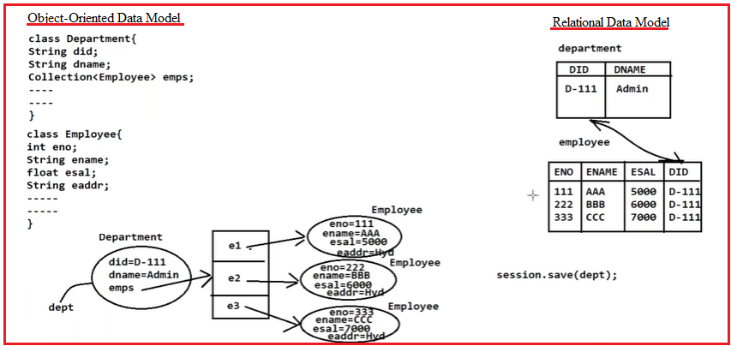

**1.Mapping Using XML tags:**

<set/list name=”name of the property” cascade=”all/..etc”>

<key name=” Id property of domain class”/>

<one-to-many class=”address of other class”/>

</set/list>

**2.Mapping Using Annatations:**

**Example:1 using xml tags.**

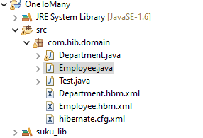

**Domain classes:**

**1.Department.java**

**package** com.hib.domain;

**import** java.util.Set;

**public** **class** Department {

**private** **int** dId;

**private** String dName;

**private** Set<Employee> dEmp;

**public** **int** getdId() {

**return** dId;

}

**public** **void** setdId(**int** dId) {

**this**.dId = dId;

}

**public** String getdName() {

**return** dName;

}

**public** **void** setdName(String dName) {

**this**.dName = dName;

}

**public** Set getdEmp() {

**return** dEmp;

}

**public** **void** setdEmp(Set dEmp) {

**this**.dEmp = dEmp;

}

}

**2.Employee.java**

**package** com.hib.domain;

**public** **class** Employee {

**private** **int** eid;

**private** String eName;

**private** **float** eSal;

**private** String eAddr;

**public** **int** getEid() {

**return** eid;

}

**public** **void** setEid(**int** eid) {

**this**.eid = eid;

}

**public** String geteName() {

**return** eName;

}

**public** **void** seteName(String eName) {

**this**.eName = eName;

}

**public** **float** geteSal() {

**return** eSal;

}

**public** **void** seteSal(**float** eSal) {

**this**.eSal = eSal;

}

**public** String geteAddr() {

**return** eAddr;

}

**public** **void** seteAddr(String eAddr) {

**this**.eAddr = eAddr;

}

}

**Hibernate Mapping Files:**

**1.Department.hbm.xml**

<?xml version=*"1.0"* encoding=*"UTF-8"*?>

<!DOCTYPE hibernate-mapping PUBLIC

"-//Hibernate/Hibernate Mapping DTD 3.0//EN"

"http://www.hibernate.org/dtd/hibernate-mapping-3.0.dtd">

<hibernate-mapping>

<class name=*"com.hib.domain.Department"* table=*"dept"*>

<id name=*'dId'* column=*"did"* length=*"5"*/>

<property name=*"dName"* column=*"dname"* length=*"7"*/>

<set name=*"dEmp"* cascade=*"all"*>

<key column=*"dId"*/>

<one-to-many class=*"com.hib.domain.Employee"*/>

</set>

</class>

</hibernate-mapping>

**2.Employee.hbm.xml**

<?xml version=*"1.0"* encoding=*"UTF-8"*?>

<!DOCTYPE hibernate-mapping PUBLIC

"-//Hibernate/Hibernate Mapping DTD 3.0//EN"

"http://www.hibernate.org/dtd/hibernate-mapping-3.0.dtd">

<hibernate-mapping>

<class name=*"com.hib.domain.Employee"* table=*"employee"*>

<id name=*"eid"* column=*"eid"* length=*"3"*/>

<property name=*"eName"* column=*"ename"* length=*"10"*/>

<property name=*"eSal"* column=*"esal"* length=*"5"*/>

<property name=*"eAddr"* column=*"eaddr"* length=*"7"*/>

</class>

</hibernate-mapping>

**Hibernate Configuration File**

<?xml version=*"1.0"* encoding=*"UTF-8"*?>

<!DOCTYPE hibernate-configuration PUBLIC

"-//Hibernate/Hibernate Configuration DTD 3.0//EN"

"http://www.hibernate.org/dtd/hibernate-configuration-3.0.dtd">

<hibernate-configuration>

<session-factory>

<property name=*"hibernate.connection.driver_class"*>oracle.jdbc.OracleDriver</property>

<property name=*"hibernate.connection.url"*>jdbc:oracle:thin:@localhost:1521:xe</property>

<property name=*"hibernate.connection.username"*>system</property>

<property name=*"hibernate.connection.password"*>tiger</property>

<property name=*"hibernate.dialect"*>org.hibernate.dialect.OracleDialect</property>

<property name=*"hibernate.hbm2ddl.auto"*>create</property>

<property name=*"show_sql"*>true</property>

<mapping resource=*"com/hib/domain/Department.hbm.xml"*/>

<mapping resource=*"com/hib/domain/Employee.hbm.xml"*/>

</session-factory>

</hibernate-configuration>

**Client Application: Test.java**

**package** com.hib.domain;

**import** java.util.HashSet;

**import** java.util.Set;

**import** org.hibernate.Session;

**import** org.hibernate.SessionFactory;

**import** org.hibernate.Transaction;

**import** org.hibernate.cfg.Configuration;

**public** **class** Test {

**public** **static** **void** main(String[] args) {

Configuration cfg=**new** Configuration();

cfg.configure("com/hib/domain/hibernate.cfg.xml");

SessionFactory sf=cfg.buildSessionFactory();

Session s=sf.openSession();

Transaction t=s.beginTransaction();

Department d=**new** Department();

Employee e1=**new** Employee();

Employee e2=**new** Employee();

e1.setEid(1);

e1.seteName("suku");

e1.seteSal(7000);

e1.seteAddr("nlr");

e2.setEid(2);

e2.seteName("sv");

e2.seteSal(9000);

e2.seteAddr("nlr");

Set<Employee> ss=**new** HashSet<Employee>();

ss.add(e1);

ss.add(e2);

d.setdId(7);

d.setdName("mca");

d.setdEmp(ss);

**int** pk=(Integer)s.save(d);

**if**(pk==7) {

System.***out***.println("Record inserted");

t.commit();

}

**else** {

System.***out***.println("Record not inserted");

}

}

}

**Output:**

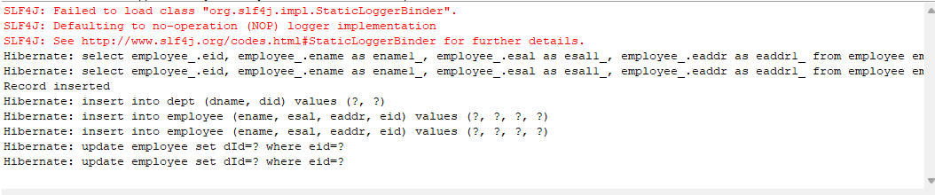

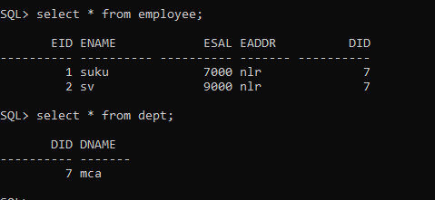

**Example:2**

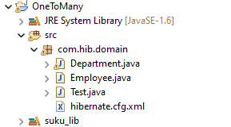

**Annotated classes/domain classes:**

**1.Department.java**

**package** com.hib.domain;

**import** java.util.Set;

**import** javax.persistence.CascadeType;

**import** javax.persistence.Column;

**import** javax.persistence.Entity;

**import** javax.persistence.Id;

**import** javax.persistence.OneToMany;

**import** javax.persistence.Table;

@Entity

@Table(name="dept")

**public** **class** Department {

@Id

@Column(name="did", length=10)

**private** **int** dId;

@Column(name="dName",length=10)

**private** String dName;

@OneToMany(cascade=CascadeType.***ALL***)

**private** Set<Employee> dEmp;

**public** **int** getdId() {

**return** dId;

}

**public** **void** setdId(**int** dId) {

**this**.dId = dId;

}

**public** String getdName() {

**return** dName;

}

**public** **void** setdName(String dName) {

**this**.dName = dName;

}

**public** Set getdEmp() {

**return** dEmp;

}

**public** **void** setdEmp(Set dEmp) {

**this**.dEmp = dEmp;

}

}

**2.Employee.java**

**package** com.hib.domain;

**import** javax.persistence.Column;

**import** javax.persistence.Entity;

**import** javax.persistence.Id;

**import** javax.persistence.Table;

@Entity

@Table(name="employee")

**public** **class** Employee {

@Id

@Column(name="eid",length=10)

**private** **int** eid;

@Column(name="eName",length=10)

**private** String eName;

@Column(name="eSal",length=10)

**private** **float** eSal;

@Column(name="eAddr",length=10)

**private** String eAddr;

**public** **int** getEid() {

**return** eid;

}

**public** **void** setEid(**int** eid) {

**this**.eid = eid;

}

**public** String geteName() {

**return** eName;

}

**public** **void** seteName(String eName) {

**this**.eName = eName;

}

**public** **float** geteSal() {

**return** eSal;

}

**public** **void** seteSal(**float** eSal) {

**this**.eSal = eSal;

}

**public** String geteAddr() {

**return** eAddr;

}

**public** **void** seteAddr(String eAddr) {

**this**.eAddr = eAddr;

}

}

**Hibernate configuration file:hibernate.cfg.xml**

<?xml version=*"1.0"* encoding=*"UTF-8"*?>

<!DOCTYPE hibernate-configuration PUBLIC

"-//Hibernate/Hibernate Configuration DTD 3.0//EN"

"http://www.hibernate.org/dtd/hibernate-configuration-3.0.dtd">

<hibernate-configuration>

<session-factory>

<property name=*"hibernate.connection.driver_class"*>oracle.jdbc.OracleDriver</property>

<property name=*"hibernate.connection.url"*>jdbc:oracle:thin:@localhost:1521:xe</property>

<property name=*"hibernate.connection.username"*>system</property>

<property name=*"hibernate.connection.password"*>tiger</property>

<property name=*"hibernate.dialect"*>org.hibernate.dialect.OracleDialect</property>

<property name=*"hibernate.hbm2ddl.auto"*>create</property>

<property name=*"show_sql"*>true</property>

<mapping class=*"com.hib.domain.Department"*/>

<mapping class=*"com.hib.domain.Employee"*/>

</session-factory>

</hibernate-configuration>

**ClientApplication:Test.java**

**package** com.hib.domain;

**import** java.util.HashSet;

**import** java.util.Set;

**import** org.hibernate.Session;

**import** org.hibernate.SessionFactory;

**import** org.hibernate.Transaction;

**import** org.hibernate.cfg.Configuration;

**public** **class** Test {

**public** **static** **void** main(String[] args) {

Configuration cfg=**new** Configuration();

cfg.configure("com/hib/domain/hibernate.cfg.xml");

SessionFactory sf=cfg.buildSessionFactory();

Session s=sf.openSession();

Transaction t=s.beginTransaction();

Department d=**new** Department();

Employee e1=**new** Employee();

Employee e2=**new** Employee();

e1.setEid(1);

e1.seteName("suku");

e1.seteSal(7000);

e1.seteAddr("nlr");

e2.setEid(2);

e2.seteName("sv");

e2.seteSal(9000);

e2.seteAddr("nlr");

Set<Employee> ss=**new** HashSet<Employee>();

ss.add(e1);

ss.add(e2);

d.setdId(7);

d.setdName("mca");

d.setdEmp(ss);

**int** pk=(Integer)s.save(d);

**if**(pk==7) {

System.***out***.println("Record inserted");

t.commit();

}

**else** {

System.***out***.println("Record not inserted");

}

}

}

Output:

